# WEBSITE FOR REAL ESTATE MANAGEMENT SYSTEM

## 

## PROJECT REPORT

Submitted in partial fulfilment of the requirements for the award of the degree of

**BACHELOR OF SCIENCE IN COMPUTER TECHNOLOGY**

### At the Bharathiar University



By

**GUHAN .K B**

**(Reg. No: 211CT018)**

Under the Guidance of

**Dr. V. Manimekalai M.C.A., M.Phil., Ph.D.**

### Assistant Professor

#### DEPARTMENT OF COMPUTER TECHNOLOGY



# Dr. N.G.P. ARTS AND SCIENCE COLLEGE

(An Autonomous Institution, Affiliated to Bharathiar University, Coimbatore)

Approved by Government of Tamil Nadu & Accredited by NAAC with ‘A’ Grade

Dr. N.G.P.-Kalapatti Road, Coimbatore-641 048, Tamil Nadu, India.

Website: www.drngpasc.ac.in | Email: info@drngpasc.ac.in | Phone: +91-422-2369100

**APRIL - 2024**

# DECLARATION

I, **Mr. K.B. GUHAN (Reg. No: 211CT018)** hereby declare that the project report entitled

“**WEBSITE FOR REAL ESTATE / HOME MANAGEMENT SYSTEM**” submitted to

Bharathiar university in partial fulfilment of the requirement for the award of the degree of **Bachelor of Science in Computer Technology,** is a record of original project work done during the period of study under the supervision and guidance of **Dr.V.MANIMEKALAI MCA.,M.Phil.,Ph.D. Assistant Professor, Department of Computer Technology, Dr. N.G.P. Arts and Science College, Coimbatore – 48**, and it has not formed on the basis of award of any Degree/ Diploma/ Associateship/ Fellowship or other similar title to any candidate of any university.

**Mr. GUHAN. K.B**

**Reg. No.: 211CT018**

**Place: Coimbatore**

**Date:**

# CERTIFICATE

This is to certify that the project entitled **“WEBSITE FOR REAL ESTATE MANAGEMENT SYSTEM”** submitted to Bharathiar university, Coimbtore-46 in partial fulfillment of the requirement for the award of degree of **BACHELOR OF SCIENCE IN**

**COMPUTER TECHNOLOGY** is a record of original project work done **Mr. GUHAN. K. B**

**(Reg. No.: 211CT018)** during the period (2019-2022) of his study in **Department of**

**Computer Technology, Dr. N.G.P. Arts and Science College, Coimbatore-48** under my

supervision and guidance, and the project has not formed the basis for the award of any Degree/

Diploma/ Associateship/ Fellowship or other similar title to any candidate of any university.

|  |  |  |
| --- | --- | --- |
| **(Dr.V.Manimekalai)** | **(Dr.M.Rathi)** | **(Dr.K.Ramamurthi**) |
| Project Guide | Associate Professor and Head | Principal |

Place: Coimbatore

Date:

Viva-voce Examination held on ________________

**Internal Examiner External Examiner**

**ACKNOWLEDGEMENT**

This project was the most significant accomplishment in my life and it would not have been possible without the blessing of God almighty and those who supported and believed in my caliber.

I record my deep sense of gratitude to **Dr. Nalla. G. Palaniswami M.D, AB (USA), Chairman, Dr.N.G.P. Research and Educational Trust and Dr. Thavamani. D. Palaniswami M.D, AB (USA), Secretary, Dr. N.G.P. Arts and Science College, Coimbatore** for providing an opportunity to undergo my study in this prestigious institution.

I record my sincere thanks to Prof**. Dr. K.Ramamurthi M.Com., BL., MBA., M.Phil., Ph.D., Dr. N.G.P. Arts and Science College, Coimbatore,** for permitting me to make use of this infrastructure for this great institution of enduring excellence.

I am immensely greatful to Prof. **Dr. F. Mary Magdalene Jane M.C.A., M.Phil., Ph.D., Dean Faculty of Computer Science, Dr. N.G.P. Arts and Science College, Coimbatore,** for every help she rendered during the project.

I express my sincere thanks to **Dr. M. Rathi MCA., M.Phil., SET, Ph.D., Associate Professor and Head, Department of Computer Technology, Dr. N.G.P. Arts and Science College, Coimbatore** for showing sustained interest and providing help throughout the period of this work.

I would like to extend the sincere thanks to my guide **Dr. V. Manimekalai MCA., M.Phil., Ph.D., Assistant Professor, Department of Computer Technology, Dr. N.G.P. Arts and Science College, Coimbatore** for her exemplary guidance and encouragement.

I take this opportunity to acknowledge my sincere thanks to all the staff members of the Department of Computer Applications for their constant inspiration, assistance and resourceful guidance for the completion of this project successfully.

I express my sincere thanks to my family and friends for their encouragement, love, prayer, moral support, advice and sacrifice without which we would not have been able to pursue the course of this study.

**TABLE OF CONTENT**

|  |  |  |  |
| --- | --- | --- | --- |
| **S. No.** | **PARTICULARS** | | **Page No.** |
|  |  | **ABSTRACT** | 1 |
| **1** |  | **INTRODUCTION** | 2 |
|  | 1.1. | Overview of the project | 2 |
| 1.2. | About the organization | 3 |
| **2** |  | **SYSTEM ANALYSIS** | 5 |
|  | 2.1. | Existing System | 5 |
| 2.2. | Proposed System | 5 |
| **3** |  | **COMPONENTS REQUIREMENTS** | 6 |
|  | 3.1. | Hardware Requirements | 6 |
| 3.2. | Software requirements | 6 |
| **4** |  | **SYSTEM OVERVIEW** | 7 |
|  | 4.1. | Module description | 7 |
| 4.2. | Software Description | 20 |
| **5** |  | **SYSTEM DESIGN** | 22 |
|  | 5.1. | Data Flow Diagram | 22 |
| 5.2. | Database Design and ER Diagran | 23 |
| 5.3. | Form design | 24 |
| 5.4. | Flow chart | 25 |
| **6** |  | **SYSTEM TESTING AND IMPLEMENTATION** | 26 |
|  | 6.1. | System Testing | 26 |
| 6.2. | System Implementation | 29 |
| **7** |  | **CONCLUSION** | 30 |
| **8** |  | **FUTURE ENHANCEMENT** | 31 |
| **9** |  | **BIBLIOGRAPHY** | 32 |
| **10** |  | **APPENDIX** | 33 |
|  | 10.1. | Screenshots | 33 |
|  | 10.2. | Sample coding | 35 |

## ABSTRACT

Real Estate Management System (REMS) is an online real estate web application that manages the activities and processes, starting from the management of the property, to the management of real estate agencies, agents, clients and. It provides comprehensive reports for managing the Real Estate agency performance and efficiency and enables the management for a better decision-making. REMS is affordable for all sizes of sales or for rent, it scales smoothly to your requirements. As complete real estate management website, REMS can provide your business with immediate and ongoing benefits, meaning better margins and cost efficiencies in all aspects of the business. This system linked all offices with a shared central data base , Each office has own local database and the shared central data base was linked with each office. It has ability to manage the daily operation performed by office such as sale , lease , ask , bid and so on. All information about habitation of lessees is very important in this system. These information are shared by all offices. The Real Estate System is designed with a way that allow the user to use the Internet Explorer as main interface (Web Enable Application).On the main interface of the centralized data base customers can search for asks or bids on the properties.

The main objective of the Property Management System is to manage the details of Approvals, Property, Registrations, Property Type. It manages all the information about Buyers, Property Type, Sellers. The project is totally built at administrative end and thus only the administrator is guaranteed the access. The purpose of the project is to build an application program to reduce the manual work for managing the Approvals, Property. It tracks all the details about the Property , Registrations, Property Type.

## 1. INTRODUCTION

### 1.1 OVERVIEW OF THE PROJECT

There are large numbers of commercial real estate online information service providers offering a suite of commercial properties and services tailored to the national and local needs of the commercial investments industry. These online marketplaces have thousands of commercial real estate properties for sale and lease under various categories including commercial office space, industrial, single - family, multi - family, land, etc both for sale and lease as well. There purpose it to attract community of industry professionals including investors, property managers, landlords, appraisers, local and national buyers to select the properties with desired features.

In this increasingly demanding scenario for a platform which could help buyers to have a look at the available property listings with all its photographs, necessary specification and description, this application is an effort to provide such a web interface with some attractive and innovative features using the latest technologies. Real Estate Web Application is an AJAX enabled website with the latest AJAX controls giving attractive and interactive look to the web pages.

The most significant feature in these websites is the interactive search criterion which lets the buyer specify their requirements to get the correct set of records from the database. The search tool should be strong enough to include all the required features which a buyer may desire. Also, each search requires a post back call to the database to retrieve some set of records but making the website AJAX enabled prevents the annoying post backs. Thus, each call refreshes just the data grid to display the listings rather the whole web page. Some other new features like drag and drop tool to save the listings, retrieving related results for each search, etc make this application more feature rich.

### 1.2 ABOUT THE ORGANIZATION

ACCENT TECHNO SOFT (ATS) provides a wide range of solutions in IT Consulting, Technology and Operations space for their clients. To enhance the business value of their service offerings to customers, they have formed strategic alliances with industry bodies, technologies vendors and system integrators. Through these partnerships they are able to deliver industry best end to end solutions to their customers. Accent was founded by experienced software profession and providing the foundation for the company's expertise in E-commerce/web applications, custom application development, data warehousing, enterprise management (support, maintenance, implementation) Accent techno soft, specializes in the business of software training & HR Consultancy spotlight in India.

Accent provides comprehensive and cost-effective training for individuals looking to inflate their IT skills in their current profession or looking to take the first step towards new careers. The success of the customers is realized through training session, but the Accent is based on inspiring students and companies to become more productive and successful in their daily activities.

## 2. SYSTEM ANALYSIS

### 2.1 EXISTING SYSTEM

The present system is not dunce proof and has certain drawbacks. Being a manual system the possible limitations and loopholes in the present system is large. The current system has too much manual work from filling a form to filing a document, delivering manifesto. This increases burden on workers but does not yield the results it should. In current system if any modification is to be made it increases manual work and is error prone. As the system is managed and maintained by workers errors are some of the possibilities.

### 2.2 PROPOSED SYSTEM

Our proposed system give all the features provided by the traditional existing systems, but instead of working only with non-spatial database, the system also works with spatial data. The system will have the following prominent features- Specification based searching This feature provides the related information to the users according to the specification they have provided to the website. For e.g., if a user is looking for a house with 1bhk at 9 lakhs at Thane, then only those properties which satisfy the aforementioned demand will be returned to the user Adding property for sale A user can add his property that he is willing to sale so that it can be viewed by other potential clients focused in similar property. For this purpose the client is supposed to enter not only the location but also pictures and the cost at which he is willing to sale that property.

## 3.SYSTEM REQUIREMENTS

### 3.1 HARDWARE REQUIREMENTS

* Intel core i2 or Equivalent or New.
* 2GB RAM or More Capacity.
* 250 GB Hard disk Capacity.

### 3.2 SOFTWARE REQUIREMENTS

* Operating System: Windows 7 / Windows 8 / Windows 10.
* Front End: HTML, CSS.
* Back End: PHP.

## 4.SYSTEM OVERVIEW

**4.1. MODULE DESCRIPTION:**

* **Admin Module**
* **User Module**

### ADMIN MODULE

* **Admin login / logout function** 
  1. One portal admin ID and password will be assigned
  2. Change Admin password

* **Member list** 
  + Tabulate list base on Member Name, Member Id, Date of Birth, and Email Id
  + Search function for Member’s name
  + Add / Edit / Delete registered users
  + Sort functions for Member Name, Member Id, Date of Birth, and Email Id
* **Post-A- Property list** –
  + Tabulated list base on Project Name, Property Type (HDB / Private / Commercial), Rent/Sales, District, Price, Published Date, Expiry Date, Member Name, Status (Active/Inactive)
  + Search function base on Member’s name and posted date of the Property
  + View / Delete / Publish Property
  + Property will only publish after Admin has been notified and approved

### USER MODULE

❖ **General User (Visitor)**

* + User can visit the site portal to get the property information
  + User can search the property by some condition
  + User can search in two ways: First is Simplified Search and second is Advance Search
  + By clicking on any property Image or More Details, user can get all details about property
  + User can get the Agent/Owner Details also of Selected Property ❖ **Services**

Portal Provides different service like:

* + Feedback
  + Enquiry
  + Useful link

**4.2 SOFTWARE DESCRIPTION**

### HTML

The **Hyper Text Mark up Language or HTML** is the standard mark up language for documents designed to be displayed in a web browser. It can be assisted by technologies such as Cascading Style Sheets and scripting languages such as JavaScript. **CSS**

**Cascading Style Sheets** is a style sheet language used for describing the presentation of a document written in a markup language such as **HTML**. **CSS** is a cornerstone technology of the World Wide Web, alongside **HTML** and **JavaScript**.

### PHP

**PHP** is a general-purpose scripting language geared toward web development. It was originally created by Danish-Canadian programmer Rasmus Lerdorf in 1994.The PHP reference implementation is now produced by The PHP Group PHP originally stood for Personal Home Page, but it now stands for the recursive initialism **PHP: Hypertext Preprocessor**

PHP code is usually processed on a web server by a PHP interpreter implemented as a module, a daemon or as a Common Gateway Interface (CGI) executable. On a web server, the result of the interpreted and executed PHP code – which may be any type of data, such as generated HTML or binary image data – would form the whole or part of an HTTP response. Various web template systems, web content management systems, and web frameworks exist which can be employed to orchestrate or facilitate the generation of that response. Additionally, PHP can be used for many programming tasks outside the web context, such as standalone graphical applications and robotic drone control. PHP code can also be directly executed from the command line.

### MY SQL

**MySQL** is an open-source relational database management system (RDBMS). Its name is a combination of "My", the name of co-founder Michael Widenius's daughter, and "SQL", the abbreviation for Structured Query Language. A relational database organizes data into one or more data tables in which data may be related to each other; these relations help structure the data. SQL is a language programmer use to create, modify and extract data from the relational database, as well as control user access to the database.

In addition to relational databases and SQL, an RDBMS like MySQL works with an operating system to implement a relational database in a computer's storage system, manages users, allows for network access and facilitates testing database integrity and creation of backups.

MySQL is free and open-source software under the terms of the GNU General Public License, and is also available under a variety of proprietary licenses. MySQL was owned and sponsored by the Swedish company MySQL AB, which was bought by Sun Microsystems (now Oracle Corporation). In 2010, when Oracle acquired Sun, Widenius forked the open-source MySQL project to create MariaDB.

**XAMMP:**

**XAMPP** is a free and open-source cross-platform web server solution stack package developed by Apache Friends, consisting mainly of the Apache HTTP

Server, MariaDB database, in the interpreter and script written in PHP and Perl programming languages. Since most actual web server deployments use the same components as XAMPP, It makes transitioning from a local test server to a live server possible.

XAMPP's ease of deployment means a WAMP or LAMP stack can be installed quickly and simply on an operating system by a developer, with the advantage that common add-in applications such as WordPress and Joomla! can also be installed with similar ease using Bitnami.

## 5. SYSTEM DESIGN

### 5.1 DATA FLOW DIAGRAM

A data flow diagram is graphical tool used to describe and analyse movement of data through a system. These are the central tool and the basis from which the other components are developed. The transformation of data from input to output, through processed, may be described logically and independently of physical components associated with the system. These are known as the logical data flow diagrams. The physical data flow diagrams show the actual implements and movement of data between people, departments and workstations. A full description of a system actually consists of a set of data flow diagrams. Using two familiar notations Yourdon, Gane and Sarson notation develops the data flow diagrams. Each component in a DFD is labeled with a descriptive name. Process is further identified with a number that will be used for identification purpose. The development of DFD’S is done in several levels. Each process in lower level diagrams can be broken down into a more detailed DFD in the next level. The lop-level diagram is often called context diagram. It consists a single process bit, which plays vital role in studying the current system.

The process in the context level diagram is exploded into other process at the first level DFD.

The idea behind the explosion of a process into more process is that understanding at one level of detail is exploded into greater detail at the next level. This is done until further explosion is necessary and an adequate amount of detail is described for analyst to understand the process.

Larry Constantine first developed the DFD as a way of expressing system requirements in a graphical from, this lead to the modular design.

A DFD is also known as a “bubble Chart” has the purpose of clarifying system requirements and identifying major transformations that will become programs in system design. So it is the starting point of the design to the lowest level of detail. A DFD consists of a series of bubbles joined by data flows in the system.

**Level-0**

**Provide**

**Service**

Admin

To add

product

User

**Level**

**-**

**1**

**)**

**Admin**

**(**

Username

Wrong

Password

Password

Process

R

eceive

accepted

Process

Flat Available

Not Available

Process

Admin

Login

Exit

Add

Property

Checkghhgheckck

availabl

e

Flats

Add

property

logout

**Level-2 (User)**

Process

Process

Process

User

Flat

Land

House

View

Property

Available

Send Mail

Close

**5.2 DATABASE DESIGN AND ER DIAGRAM:**

**DATABASE DESIGN**

The database design involves creation of tables that are represented in physical database as stored files. They have their own existence. Each table constitute of rows and columns where each row can be viewed as record that consists of related information and column can be viewed as field of data of same type. The table is also designed with some position can have a null value. The database design of project is designed in such a way values are kept without redundancy and with normalized format.

### ER DIAGRAM

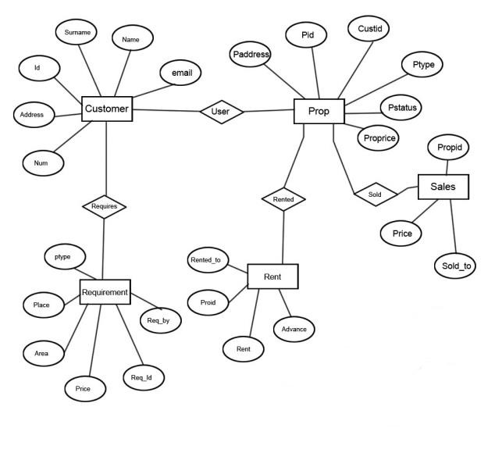

#### 5.3 FORM DESIGN

Input design is the process of converting the user-oriented. Input to a computer based format. The goal of the input design is to make the data entry easier, logical and free error. Errors in the input data are controlled by the input design. The quality of the input determines the quality of the system output.

All the data entry screen are interactive in nature, so that the user can directly enter into data according to the prompted messages. The user are also can directly enter into data according to the prompted messages. The users are also provided with option of selecting an appropriate input from a list of values. This will reduce the number of error, which are otherwise likely to arise if they were to be entered by the user itself.

Input design is one of the most important phase of the system design. Input design is the process where the input received in the system are planned and designed, so as to get necessary information from the user, eliminating the information that is not required. The aim of the input design is to ensure the maximum possible levels of accuracy and also ensures that the input is accessible that understood by the user. The input design is the part of overall system design, which requires very careful attention. If the data going into the system is incorrect then the processing and output will magnify the errors.

The objectives considered during input design are:

* Nature of input processing.
* Flexibility and thoroughness of validation rules.
* Handling of properties within the input documents.
* Screen design to ensure accuracy and efficiency of the input relationship with files.
* Careful design of the input also involves attention to error handling, controls, batching and validation procedures.

Input design features can ensure the reliability of the system and produce result from accurate data or they can result in the production of erroneous information.

**5.4 FLOW CHART:**

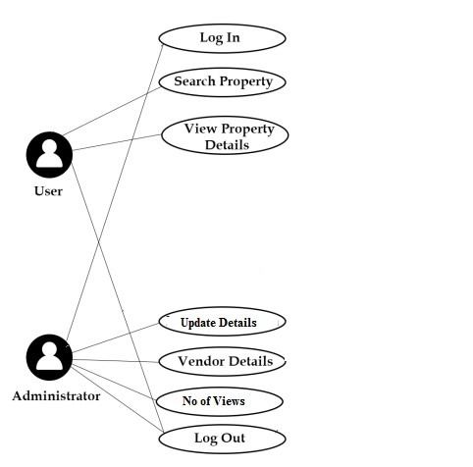

## 6. SYSTEM TESTINNG AND IMPLEMENTATION

### 6.1 SYSTEM TESTING

Software testing is a critical element of software quality assurance and represents the ultimate review of specification, design and coding. In fact, testing is the one step in the software engineering process that could be viewed as destructive rather than constructive.

A strategy for software testing integrates software test case design methods into a well-planned series of steps that result in the successful construction of software. Testing is the set of activities that can be planned in advance and conducted systematically. The underlying motivation of program testing is to affirm software quality with methods that can economically and effectively apply to both strategic to both large and small-scale systems.

**Strategic Approach to Testing :**

The software engineering process can be viewed as a spiral. Initially system engineering defines the role of software and leads to software requirement analysis where the information domain, functions, behavior, performance, constraints and validation criteria for software are established. Moving inward along the spiral, we come to design and finally to coding. To develop computer software we spiral in along streamlines that decrease the level of abstraction on each turn.

A strategy for software testing may also be viewed in the context of the spiral. Unit testing begins at the vertex of the spiral and concentrates on each unit of the software as implemented in source code. Testing progress by moving outward along the spiral to integration testing, where the focus is on the design and the construction of the software architecture. Talking another turn on outward on the spiral we encounter validation testing where requirements established as part of software requirements analysis are validated against the software that has been constructed. Finally we arrive at system testing, where the software and other system elements are tested as a whole.

### TESTING AND METHODLOGIES

System testing is the state of implementation, which is aimed at ensuring that the system works accurately and efficiently as expect before live operation, commences. It certifies that the whole set of programs hang together System testing requires a test plan that consists of several key activities and steps for run program, string, system and user acceptance testing. The implementation of newly design package is important in adopting a successful new system.

Testing is important stage in software development. System test is implementation should be a confirmation that all is correct and an opportunity to show the users that the system works as they expected It accounts the largest percentage of technical effort in software development process.

Testing phase is the development phase that validates the code against the functional specifications. Testing is a vital to the achievement of the system goals. The objective of testing is to discover errors. To fulfil this objective a series of test step such as the unit test, integration test, validation and system test where planned and executed.

## Unit Testing

Unit testing focuses verification effort on the smallest unit of software design, the module. The unit testing we have is white box oriented and some modules the steps are conducted in parallel.

### 1. WHITE BOX TESTING

This type of testing ensures that

* All independent paths have been exercised at least once
* All logical decisions have been exercised on their true and false sides
* All loops are executed at their boundaries and within their operational bounds
* All internal data structures have been exercised to assure their validity.

### 2. BASIC PATH TESTING

Established technique of flow graph with Cyclomatic complexity was used to derive test cases for all the functions. The main steps in deriving test cases were:

Use the design of the code and draw correspondent flow graph.

Determine the Cyclomatic complexity of resultant flow graph, using formula:

V(G)=E-N+2 or

V(G)=P+1 or

V(G)=Number Of Regions

Where V(G) is Cyclomatic complexity,

E is the number of edges,

N is the number of flow graph nodes,

P is the number of predicate nodes.

Determine the basis of set of linearly independent paths.

### 3. CONDITIONAL TESTING

In this part of the testing each of the conditions were tested to both true and false aspects. And all the resulting paths were tested. So that each path that may be generate on particular condition is traced to uncover any possible errors.

### 4. DATA FLOW TESTING

This type of testing selects the path of the program according to the location of definition and use of variables. This kind of testing was used only when some local variable were declared. The *definition-use chain* method was used in this type of testing. These were particularly useful in nested statements.

### 5. LOOP TESTING

In this type of testing all the loops are tested to all the limits possible. The following exercise was adopted for all loops:

* All the loops were tested at their limits, just above them and just below them.
* All the loops were skipped at least once.
* For nested loops test the inner most loop first and then work outwards.
* For concatenated loops the values of dependent loops were set with the help of connected loop.
* Unstructured loops were resolved into nested loops or concatenated loops and tested as above.

**6.2 SYSTEM IMPLEMENTATION**

In this Section we will do Analysis of Technologies to use for implementing the project.

### FRONT END HTML

Hypertext Markup Language (HTML) is the standard markup language for documents designed to be displayed in a web browser. It can be assisted by technologies such as Cascading Style Sheets (CSS) and scripting languages such as JavaScript. Web browsers receive HTML documents from a web server or from local storage and render the documents into multimedia web pages. HTML describes the structure of a web page semantically and originally included cues for the appearance of the document.

HTML elements are the building blocks of HTML pages. With HTML constructs, images and other objects such as interactive forms may be embedded into the rendered page. HTML provides a means to create structured documents by denoting structural semantics for text such as headings, paragraphs, lists, links, quotes and other items. HTML elements are delineated by tags, written using angle brackets. Tags such as <img /> and <input /> directly introduce content into the page. Other tags such as <p> surround and provide information about document text and may include other tags as sub-elements. Browsers do not display the HTML tags, but use them to interpret the content of the page.

HTML can embed programs written in a scripting language such as JavaScript, which affects the behavior and content of web pages. Inclusion of CSS defines the look and layout of content. The World Wide Web Consortium (W3C), former maintainer of the HTML and current maintainer of the CSS standards, has encouraged the use of CSS over explicit presentational HTML since 1997.

### BACK END PHP

PHP is a server side scripting language that is used to develop Static websites or Dynamic websites or Web applications. PHP stands for Hypertext Pre-processor, that earlier stood for

Personal Home Pages. PHP scripts can only be interpreted on a server that has PHP installed.

The client computers accessing the PHP scripts require a web browser only. A PHP file contains PHP tags and ends with the extension ".php".

The term PHP is an acronym for PHP: Hypertext Preprocessor. PHP is a server-side scripting language designed specifically for web development. PHP can be easily embedded in HTML files and HTML codes can also be written in a PHP file. The thing that differentiates PHP with clientside language like HTML is, PHP codes are executed on the server whereas HTML codes are directly rendered on the browser.

PHP: Hypertext Preprocessor (or simply PHP) is a general-purpose programming language originally designed for web development. It was originally created by Rasmus Lerdorf in 1994.PHP code may be executed with a command line interface (CLI), embedded into HTML code, or used in combination with various web template systems, web content management systems, and web frameworks. PHP code is usually processed by a PHP interpreter implemented as a module in a web server or as a Common Gateway Interface (CGI) executable. The web server outputs the results of the interpreted and executed PHP code, which may be any type of data, such as generated HTML code or binary image data. PHP can be used for many programming tasks outside of the web context, such as standalone graphical applications and robotic drone control.

### MySQL

MySQL is an open-source relational database management system (RDBMS) based on Structured Query Language (SQL).Its name is a combination of "My", the name of cofounder Michael Widenius's daughter, and "SQL", the abbreviation for Structured Query Language. A relational database organizes data into one or more data tables in which data types may be related to each other; these relations help structure the data. SQL is a language programmers use to create, modify and extract data from the relational database, as well as control user access to the database. In addition to relational databases and SQL, an RDBMS like MySQL works with an operating system to implement a relational database in a computer's storage system, manages users, allows for network access and facilitates testing database integrity and creation of backups.

MySQL is pretty easy to master in comparison with other database software like Oracle

Database, or Microsoft SQL Server. MySQL can run on various platforms UNIX, Linux, Windows, etc. You can install it on a server or even in a desktop. Besides, MySQL is reliable, scalable, and fast. The official way to pronounce MySQL is My Ess Que Ell, not My Sequel. However, you can pronounce it whatever you like, who cares?

MySQL is free and open-source software under the terms of the GNU General Public

License, and is also available under a variety of proprietary licenses. MySQL was owned and sponsored by the Swedish company MySQL AB, which was bought by Sun Microsystems (now Oracle Corporation).In 2010, when Oracle acquired Sun, Widenius forked the opensource MySQL project to create MariaDB.

MySQL is a component of the LAMP web application software stack (and others), which is an acronym for Linux, Apache, MySQL, Perl/PHP/Python. MySQL is used by many database-driven web applications, including Drupal, Joomla, phpBB, and WordPress. MySQL is also used by many popular websites, including Facebook, Youtube, Twitter and so on.

## 7. CONCLUSION

The Internet has become a major resource in modern business, thus Real Estate in India has gained significance not only from the entrepreneur’s but also from the customer’s point of view. For the entrepreneur, Real Estate in India generates new business opportunities and for the customer, it makes comparative search property possible. As per a survey, most consumers of online stores are impulsive and usually make a decision to stay on a site within the first few seconds. Hence we have designed the project to provide the user with easy navigation, retrieval of data and necessary feedback as much as possible.

It has been a great pleasure for me to work on this exciting and challenging project. This project proved good for me as it provided practical knowledge of not only programming in ASP.NET and C#.NET web based application and no some extent Windows Application and SQL Server, but also about all handling procedure related with **“PROJECT NAME”.** It also provides knowledge about the latest technology used in developing web enabled application and client server technology that will be great demand in future. This will provide better opportunities and guidance in future in developing projects independently.

## 8. FUTURE ENHANCEMENT

A console for the data centre may be made available to allow the personnel to monitor on the sites which were cleared for hosting during a particular period. Moreover, it is just a beginning; further the system may be utilized in various other types of Real Estate in India operation viz.

## 9. BIBLIOGRAPHY

**TEXT BOOKS:**

* LEARNING WEB DESIGN : A GUIDE TO HTML, CSS, JAVASCRIPT AND WEB

GRAPHICS : JENNIFER ROBINS , EDITION : 5E , O’REILLY MEDIA, INC, USA

* HTML & CSS: DESIGN AND BUILD WEBSITES : JON DUCKET , WILEY 1st EDITION
* PHP AND MY SQL WEB DEVELOPMENT: LUKEWELLING, LAURA

THOMSON QUE; 1st EDITION

* MICROSOFT SQL SERVER-2000 : RANKIN, PAUL & JENSEN, SAMS 2nd

EDITION

* SQL SERVER-2000 : DUSAN PETKOVIC, MC GRAW HILL EDUCATION 2nd EDITION

**REFERENCES USED:**

* http://php.net/manual/en/tutorial.php
* https://www.w3schools.com/php/default.asp
* https://www.homeandlearn.co.uk/php/php.html
* https://teamtreehouse.com/tracks/beginning-php

## 10. APPENDICES

### 10.1 SCREENSHOTS

Website View



2nd Page

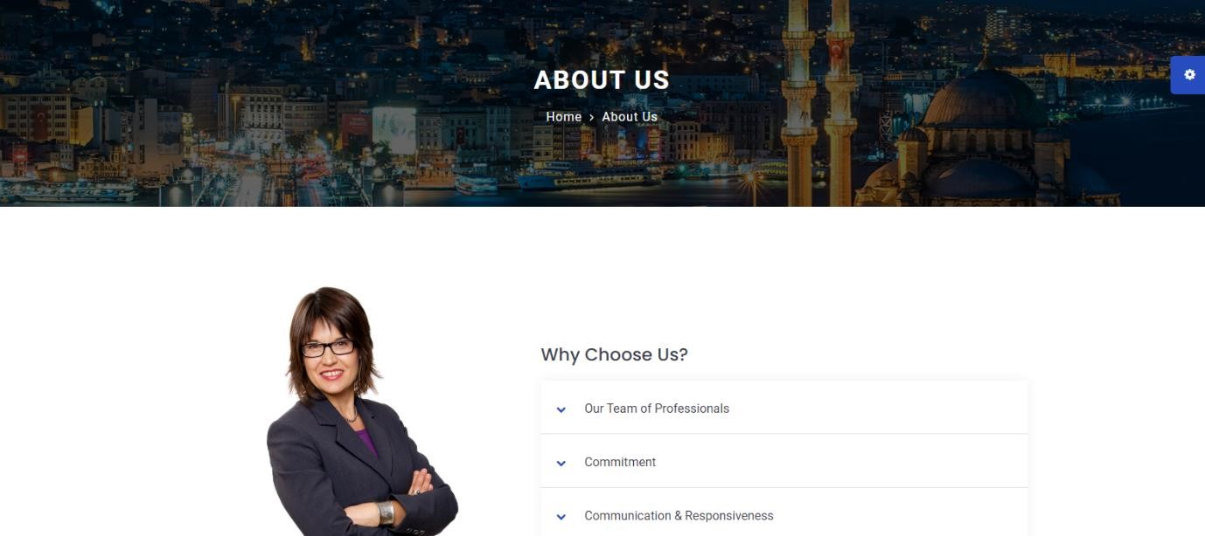

3rd Page

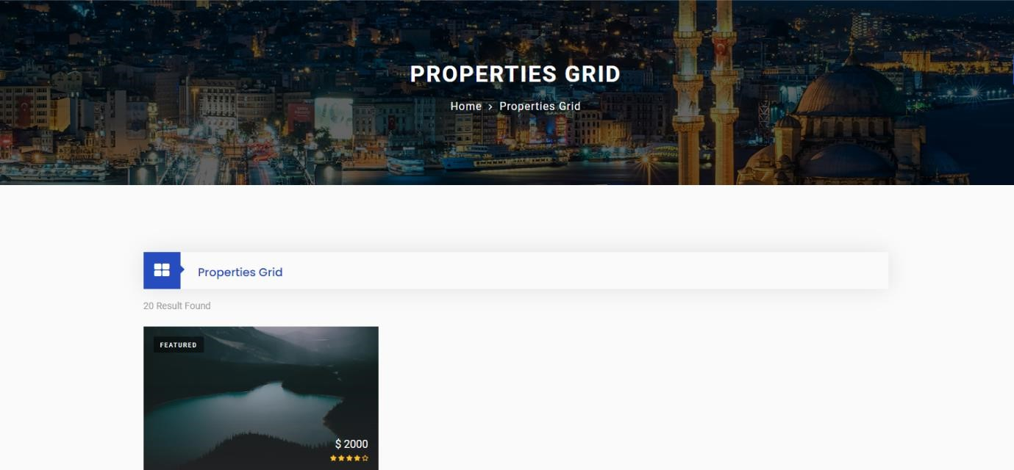

4th Page

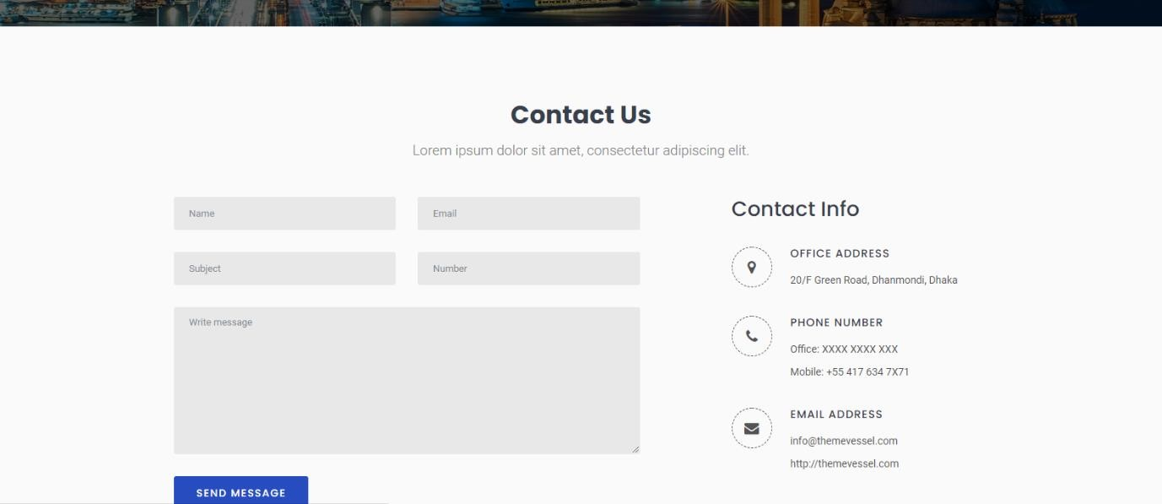

Login to Admin Page

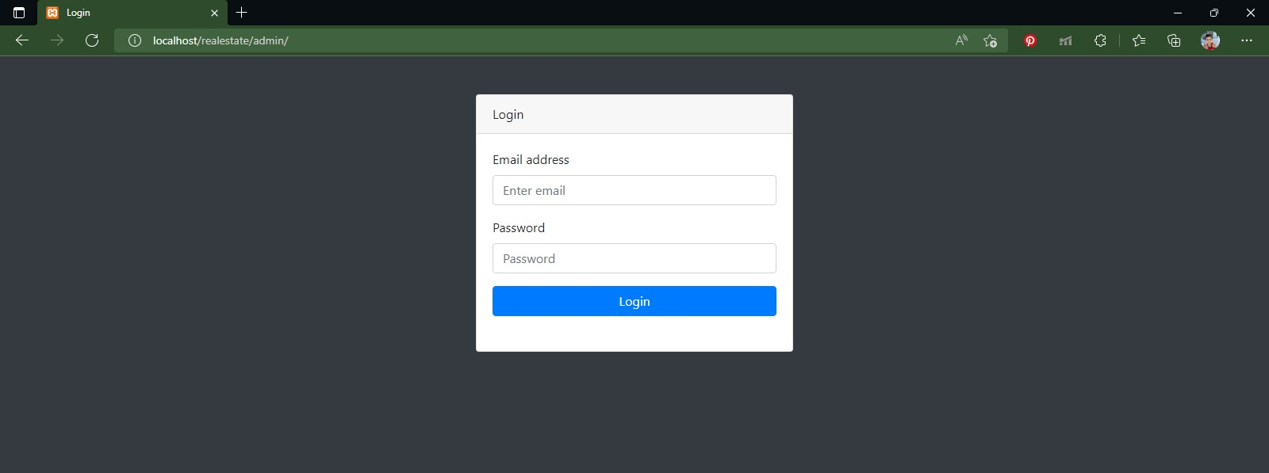

Admin Page

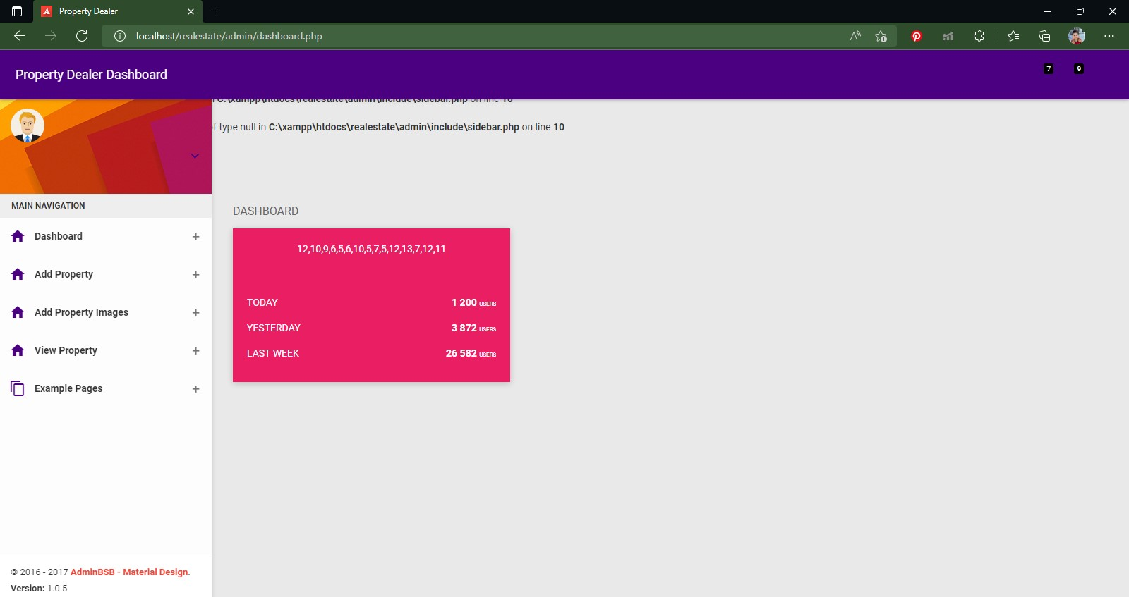

### 10.2 SAMPLE CODING

<?php include('include/header.php');?>

<!-- main header end -->

<!-- Banner start -->

<div class="banner banner-bg" id="particles-banner-wrapper">

<div id="particles-banner"></div>

<div id="carouselExampleIndicators" class="carousel slide" data-ride="carousel">

<div class="carousel-inner">

<div class="carousel-item item-bg active">

<div class="carousel-caption banner-slider-inner d-flex h-100 text-left">

<div class="carousel-content container">

<div class="t-center">

<h2 data-animation="animated fadeInDown delay-05s">Best Place For Sell Properties</h2>

<p class="text-p" data-animation="animated fadeInUp delay-10s">

This is real estate website template based on Bootstrap 4 framework.

</p>

<a data-animation="animated fadeInUp delay-10s" href="#" class="btn btn-lg btntheme">Get Started Now</a>

<a data-animation="animated fadeInUp delay-10s" href="#" class="btn btn-lg btn-white-lgoutline">Free Download</a>

</div>

</div>

</div>

</div>

<div class="carousel-item item-bg">

<div class="carousel-caption banner-slider-inner d-flex h-100 text-left">

<div class="carousel-content container">

<div class="t-right">

<h2 data-animation="animated fadeInDown delay-05s">Find Your Dream Properties</h2>

<p class="text-p" data-animation="animated fadeInUp delay-10s">

This is real estate website template based on Bootstrap 4 framework.

</p>

<a data-animation="animated fadeInUp delay-10s" href="#" class="btn btn-lg btn-round btntheme">Get Started Now</a>

<a data-animation="animated fadeInUp delay-10s" href="#" class="btn btn-lg btn-round btnwhite-lg-outline">Free Download</a>

</div>

</div>

</div>

</div>

<div class="carousel-item item-bg">

<div class="carousel-caption banner-slider-inner d-flex h-100 text-left">

<div class="carousel-content container">

<div class="t-left">

<h2 data-animation="animated fadeInUp delay-05s">Best Place For Sell Properties</h2>

<p class="text-p" data-animation="animated fadeInUp delay-10s">

This is real estate website template based on Bootstrap 4 framework.

</p>

<a data-animation="animated fadeInUp delay-10s" href="#" class="btn btn-lg btn-round btntheme">Get Started Now</a>

<a data-animation="animated fadeInUp delay-10s" href="#" class="btn btn-lg btn-round btnwhite-lg-outline">Free Download</a>

</div>

</div>

</div>

</div>

</div>

</div>

</div>

<div class="featured-properties content-area-19">

<div class="container">

<div class="main-title">

<h1>Featured Properties</h1>

<p>Lorem ipsum dolor sit amet, consectetur adipiscing elit.</p>

</div>

<div class="row">

<div class="col-lg-3 col-md-6 col-sm-6 wow fadeInLeft delay-04s">

<div class="card property-box-2">

<!-- property img -->

<div class="property-thumbnail">

<a href="properties-details.html" class="property-img">

<img src="assets/img/property-3.jpg" alt="property-3" class="img-fluid">

</a>

<div class="property-overlay">

<a href="properties-details.html" class="overlay-link">

<i class="fa fa-link"></i>

</a>

<a class="overlay-link property-video" title="Test Title">

<i class="fa fa-video-camera"></i>

</a>

<div class="property-magnify-gallery">

<a href="assets/img/property-3.jpg" class="overlay-link">

<i class="fa fa-expand"></i>

</a>

<a href="assets/img/property-7.jpg" class="hidden"></a> <a href="assets/img/property-6.jpg" class="hidden"></a>

</div>

</div>

</div>

<!-- detail -->

<div class="detail">

<h5 class="title"><a href="properties-details.html">Sweet Family Home</a></h5>

<h4 class="price">

$567.99/Night

</h4>

<p>Lorem ipsum dolor sit amet, consectetur adipisicing elit, sed do eiusmod tempor incididunt.</p>

</div>

</div>

</div>

<div class="col-lg-3 col-md-6 col-sm-6 wow fadeInUp delay-04s">

<div class="card property-box-2">

<!-- property img -->

<div class="property-thumbnail">

<a href="properties-details.html" class="property-img">

<img src="assets/img/property-7.jpg" alt="property-7" class="img-fluid">

</a>

<div class="property-overlay">

<a href="properties-details.html" class="overlay-link">

<i class="fa fa-link"></i>

</a>

<a class="overlay-link property-video" title="Test Title">

<i class="fa fa-video-camera"></i>

</a>

<div class="property-magnify-gallery">

<a href="assets/img/property-7.jpg" class="overlay-link">

<i class="fa fa-expand"></i>

</a>

<a href="assets/img/property-4.jpg" class="hidden"></a> <a href="assets/img/property-3.jpg" class="hidden"></a>

</div>

</div>

</div>

<!-- detail -->

<div class="detail">

<h5 class="title"><a href="properties-details.html">Relaxing Apartment</a></h5>

<h4 class="price">

$567.99/Night

</h4>

<p>Lorem ipsum dolor sit amet, consectetur adipisicing elit, sed do eiusmod tempor incididunt.</p>

</div>

</div>

</div>

<div class="col-lg-3 col-md-6 col-sm-6 wow fadeInUp delay-04s">

<div class="card property-box-2">

<!-- property img -->

<div class="property-thumbnail">

<a href="properties-details.html" class="property-img">